Lesson 1 Introducing WonderCam

Instructions
WonderCam is an user-friendly AI visual module with eight built-in functions: Color Recognition, Facial Recognition, AprilTag Recognition, Visual Line Following, Numeric Recognition, Landmark Recognition, Image Classification and Feature Learning.
WonderCam make learning AI fun and easy to comprehend. With 1-Click Training feature, it can readily program many creative AI visual projects.
WonderCam IIC connector works seamlessly with many global leading controllers like micro:bit, Arduino, Raspberry Pi etc. By sending the recognized result output to the controller, you can focus on project creativity without the programming complexity.

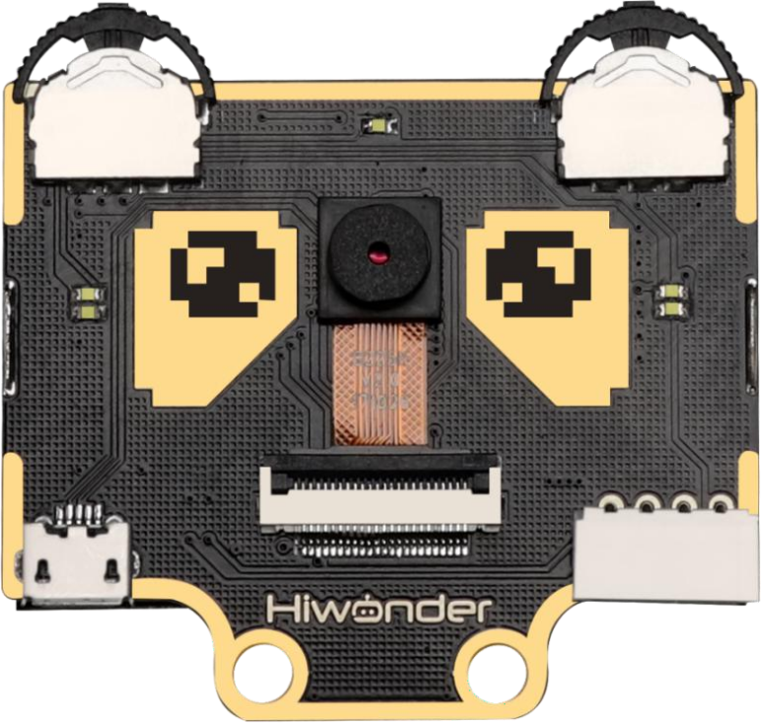

Operation Overview
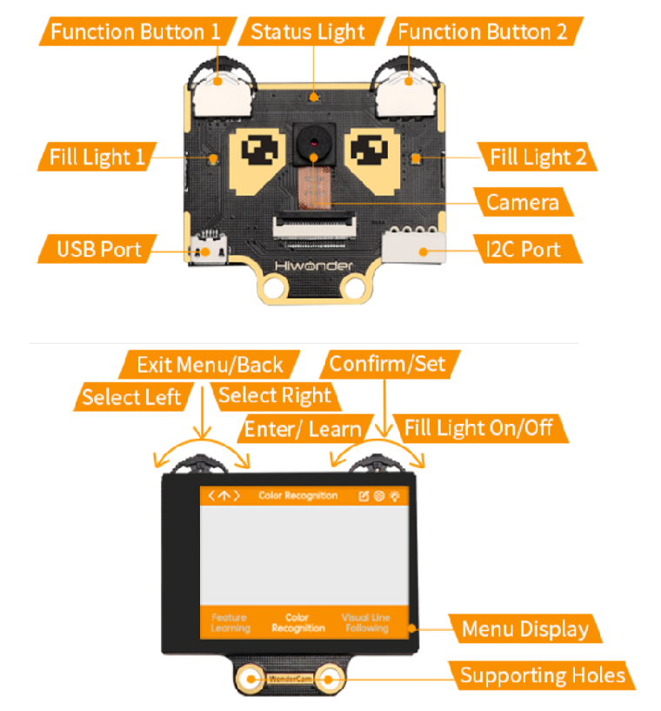

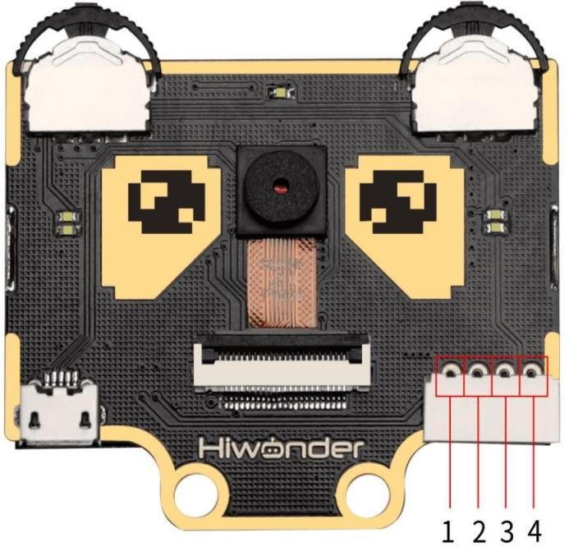

IIC Connectors Specification

S/N | Name | Function
1 | SCL | IIC Serial Clock Pin
2 | SDA | IIC Serial Data Pin
3 | GND | IIC Negative Pin
4 | 5V | 5V Positive Pin

User Learning Guideline
Step 1: Understanding WonderCam module and operating familiarization
Start with "Lesson 1 Introducing WonderCam" follow by "Lesson 2
Getting Started".

Step 2: Step by Step guide to AI Visual Module features and functions
The 8 lessons are: Color Recognition, Facial Recognition, AprilTag Recognition, Visual Line Following, Numeric Recognition, Road Sign Recognition, Image Classification and Feature Learning.

Step 3: Learn as needed
Upon experiencing all the features and functions, learner can further explore programming each features with the guideline provided for different platform.

